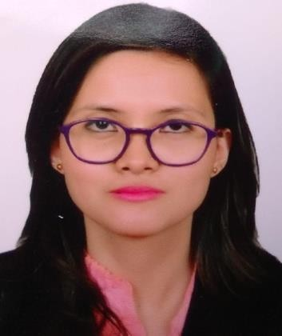
PRADIPTA SHYAM
Partha Enclave, Seuji Path, Dispur, wireless, Guwahati, Assam Pin code - 781006
Email ID - pradiptashyam@gmail.com
Mobile no. – 8105695296
University email ID:- pshyam@rgu.ac

Education Details

YEAR DEGREE INSTITUTE PERCENTAGE/CGPA
2019 | M.Sc in Forensic Science ( Specialization in Forensic Toxicology  Drugs and narcotics, questioned documents, forensic anthropology) | Jain  Deemed-to-be University, Bengaluru. | 6.67
2017 | B.Sc in Forensic Science | Jain  Deemed-to-be University,  Bengaluru | 6.42
2014 | AHSEC | Aryabhatta Junior Science College, Guwahati. | 56.2
2010 | CBSE | Kendriya Vidyalaya,  C.C.I. Bokajan | 7.4

Work Experience
- Intern at State Forensic Science Laboratory, Kahilipara, Guwahati
- Tasks include analysis of DNA Fingerprint, analysis of blood and other bodyfluids.
- One year teaching experience as a lecturer, department of forensic science at GIET College Rajahmundry, Andhra Pradesh.
- Current status Teaching Assistant at Assam Royal Global University Guwahati.

Projects and Activities
- Study on student’s perception about child pornography.
- Mini project on Autopsy at Diphu Medical College and Hospital.
- Major Project on Comparative study of Cranial and Facial indices between Indigenous male population of Assam and Monks in Assam.
- Blog article written on illegal cultivation of opium in northeast and its impact on the lives and lands drug cultivation and its livelihood.

Achievements
- Achieved Prarambhik Degree( 1st division) in Fine Arts( Painting) under Pracheen Kala Kendra, Chandigarh.

- Achieved Prarambhik part 2 Degree(2nd division) in Fine Arts( Painting) under Pracheen Kala Kendra, Chandigarh.

- Achieved 3rd in chitra bhushan ( Fine arts painting) under Pracheen Kala Kendra, Chandigarh.
Certificate program
- Participated in two days practical workshop on microbiological techniques in Forensic Science Investigation conducted by the Department of Life Science, School of Sciences,
J.C road campus, Bengaluru on 8th and 9th december 2016.

- Participated in the comprehensive Life skills, sexuality and personal safety program on 10th and 11th August 2017.
- Attended State level seminar on Forensic Biology organized by department of Forensic Science, Bengaluru on 28th july 2017.
- Attended National conference on emerging trends in Forensic Science held on 10th and 11th January 2019 at NIMHANS convention centre, Bengaluru.
- Attended Introductory workshop on Forensic Psychology on 29th March conducted by Axxonet system technologies PVT.LTD. Bengaluru.

Key Skills

- Organised
- Observant
- Empathetic
- Passionate
- Responsible
- Optimistic
- Focused
- Good Listener
- Understanding
- Creative

